**Online Diary 3:**

**Title:** To make noughts and crosses fun.

**Date:** Tuesday 20th October 2020

**3.0 Background:**

A 2-player game where each player battles it out using either a nought or a cross. To win u will have to get 3 in a row either horizontal, diagonal or vertical.

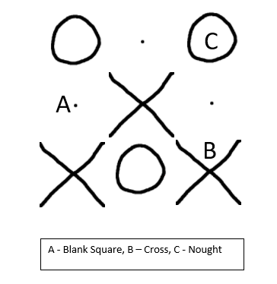

**Figure 1.** Classic Noughts and Crosses

Figure one shows the classic setup for noughts and crosses, with A representing the spaces on the grid and B and C representing the shapes, noughts and crosses, used to define the spaces taken by each player.

**3.1 Material:**

There is a link to a website where you can play the game. Therefore, you would only need a item to access the internet with to play the game.

[**https://landwere.itch.io/noughts-and-crosses**](https://landwere.itch.io/noughts-and-crosses)

This is a link to the website

**3.2 Game:**

The team has designed a chance-based version of noughts and crosses called Rolling Reverse Noughts and Crosses. This game utilises a die to decide the action the player must take during their turn. This will allow the player to progress towards the final goal. The goal of the game is to force the opponent into getting 5 in a row vertically, horizontally or diagonal. Whoever gets 5 in a row is the loser.

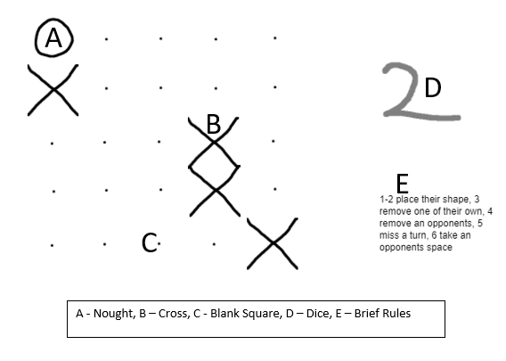

**Figure 2.** Prototype Build

This scene shows the prototype that the team developed, with A and B representing the shapes and C representing the playable board. D shows the die used during the game and E displays a brief explanation of the rules.

**Mechanics:**

* Dice roll – Used to decide on the action the player takes during the turn
* Strategic thinking – used to plan to reach the final goal
* Sabotaging system – allow players to interfere with each other’s strategies.

**Rules:**

* Players roll a die to decide who goes first, the highest number gets to decide if they go first or second.
* Players place one of their respective shapes in a space on the board before the game starts.
* At the start of each turn the players roll the die to decide on what action they can take during that turn:
  + Rolling a 1 or 2 - Allows the player to place their respective shape (either a nought or a cross).
  + Rolling a 3 - Remove one of your own shapes.
  + Rolling a 4 - Swap your shapes place with one of the other players.
  + Rolling a 5 - Miss your turn
  + Rolling a 6 - Place a shape for the other player.
* Players must always have at least one shape on the board at all times. During this time if they roll a 3, they skip their turn.
* The winner is the player that forces their opponent to complete a line of 5 in any direction.

**Play testing:**

The team had done both internal and external playtesting. Some issues that were encountered during the internal playtesting are:

* Impossible to remove your own or opponents shape when rolling a 3 or 4.
* Able to play out of turn
* Does not let players know who the winner or loser is.
* Rules were not clearly defined.

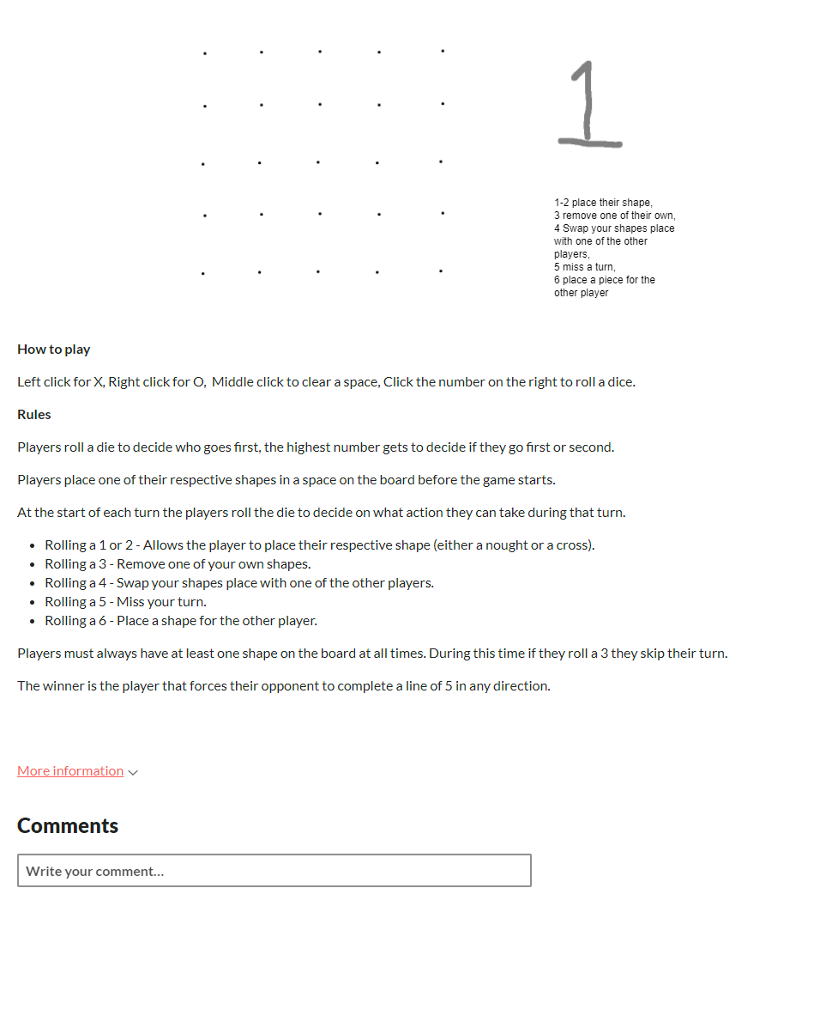

B

A

**Figure 3.** Game Page

A - Shows the final game window with the board and die.

B - Shows the instructions of the how to play the game on the site and the rules the player must follow.

During the external playtesting, some of the things that were brought up were:

* Make the board shorter so the play time is quicker.
* Accessibility of the game was easy to learn

Changes made to the game after internal and external playtesting:

* Able to remove a nought or a cross from the game.
* Rules were refined to make them more clear
* Game page was reworked to make it easier to understand how it operated. This is shown in figure 3.

**Project members:**

The group had consisted of Connor Winspur, Cory Arnett-O’Brien, Ngozi Egonu and Akash Sroay.

The external play testers were Jessica Evans, Hou Yap, Joshua Baker, Zakaria Ahmed.